KISII SCHOOL 2025 PREDICTION


(KCSE PRE-ANALYSIS TEST)
232/3
PHYSICS
PAPER 3 (PRACTICAL)
TIME: 2½ HOURS

NAME……………………………………………………………………………………….
SCHOOL……………………………………………… SIGN………………………..
INDEX NO……………………………………………. ADM NO……………………
Instruction to The Candidates
- Write your name and Index number in the space provided above.
- Answer all questions in the space provided in the question paper
- You are supposed to spend the first 15 minutes of the 2½ hours allowed for this paper reading the whole paper carefully before commencing your work.
- Marks are given for clear record of the observation made, their suitability accuracy and the use made of them.
- Candidates are advised to record their observation as soon as they are made.
- Non-programmable silent calculators and mathematical tables may be used.
For Examiners Use Only
Question 1
Part | h(iii) | V | Vi | V(I) | V(II) | Total
Max score | 1 | 6 | 5 | 3 | 3 | 18
score
Question 2 A
part | a | b | C(i) | C(ii) | e | f | g | h | Total
Max score | 1 | 2 | 1 | 2 | 2 | 1 | 3 | 3 | 15
score
Question 2(B)
part | c | e | f | g(I) | g(II) | Total
Max score | 1 | 1 | 1 | 2 | 3 | 7
score

1. You are provided with the following:
a) Two biconcave lenses,
b) Two lens holders
c) lit candle
d) White screen, I (with cross-wire)
e) White screen (II)
f) A meter rule
g) A plane mirror
h) Cellotape

Procedure
i) Mount 1st lens in the lens holder. Fix the plane mirror at the back of the lens using cellotape
ii) Arrange the setup as shown in figure below.
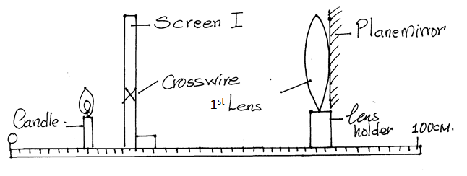
iii)Adjust the position of the lens with the mirror using a sharp image of the cross-wire is formed on the screen I beside the cross-wires, measure the distance L₁ between screen I and lens A
L₁ …………………………………………………. (1mk)

iv)Remove the mirror from the lens. Re-arrange the candle, screen I, screen II 1st lens and 2nd lens as in the figure below.
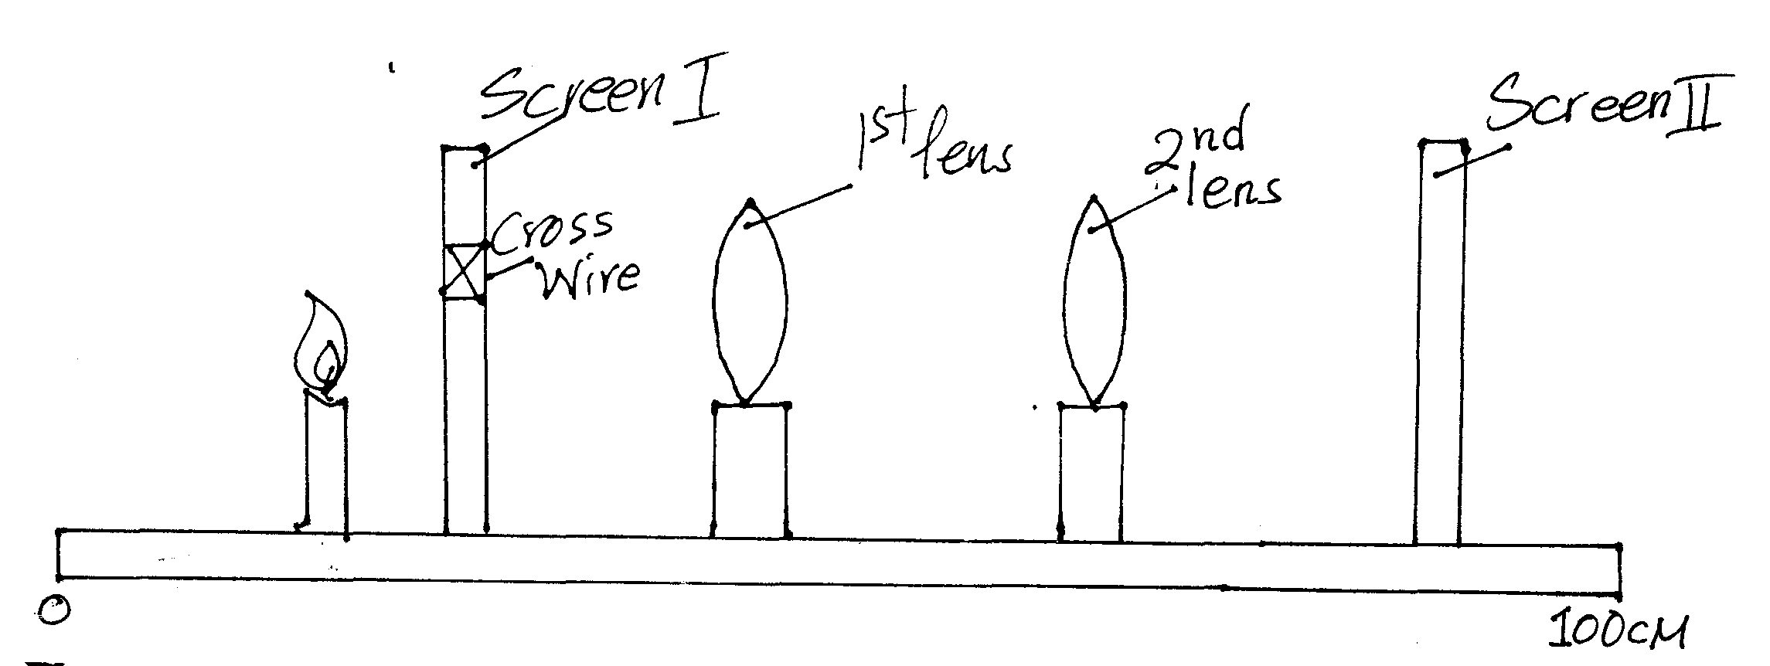

v) Set the distance between screen I and 1st lens to be 40cm ensure this distance is maintained throughout the rest of the experiment. Set the distance between 1st and 2nd lens to be 30cm. Adjust the position of the screen II to obtain a sharp image of the cross – wire on it. Measure the distance V between 2nd lens and screen II. Record values in the table below.

d(cm) | 30 | 35 | 40 | 45 | 50 | 55 | 60 | 65 | 70
V(cm)

(6mks)
vi) Plot a graph of V against d (5mks)
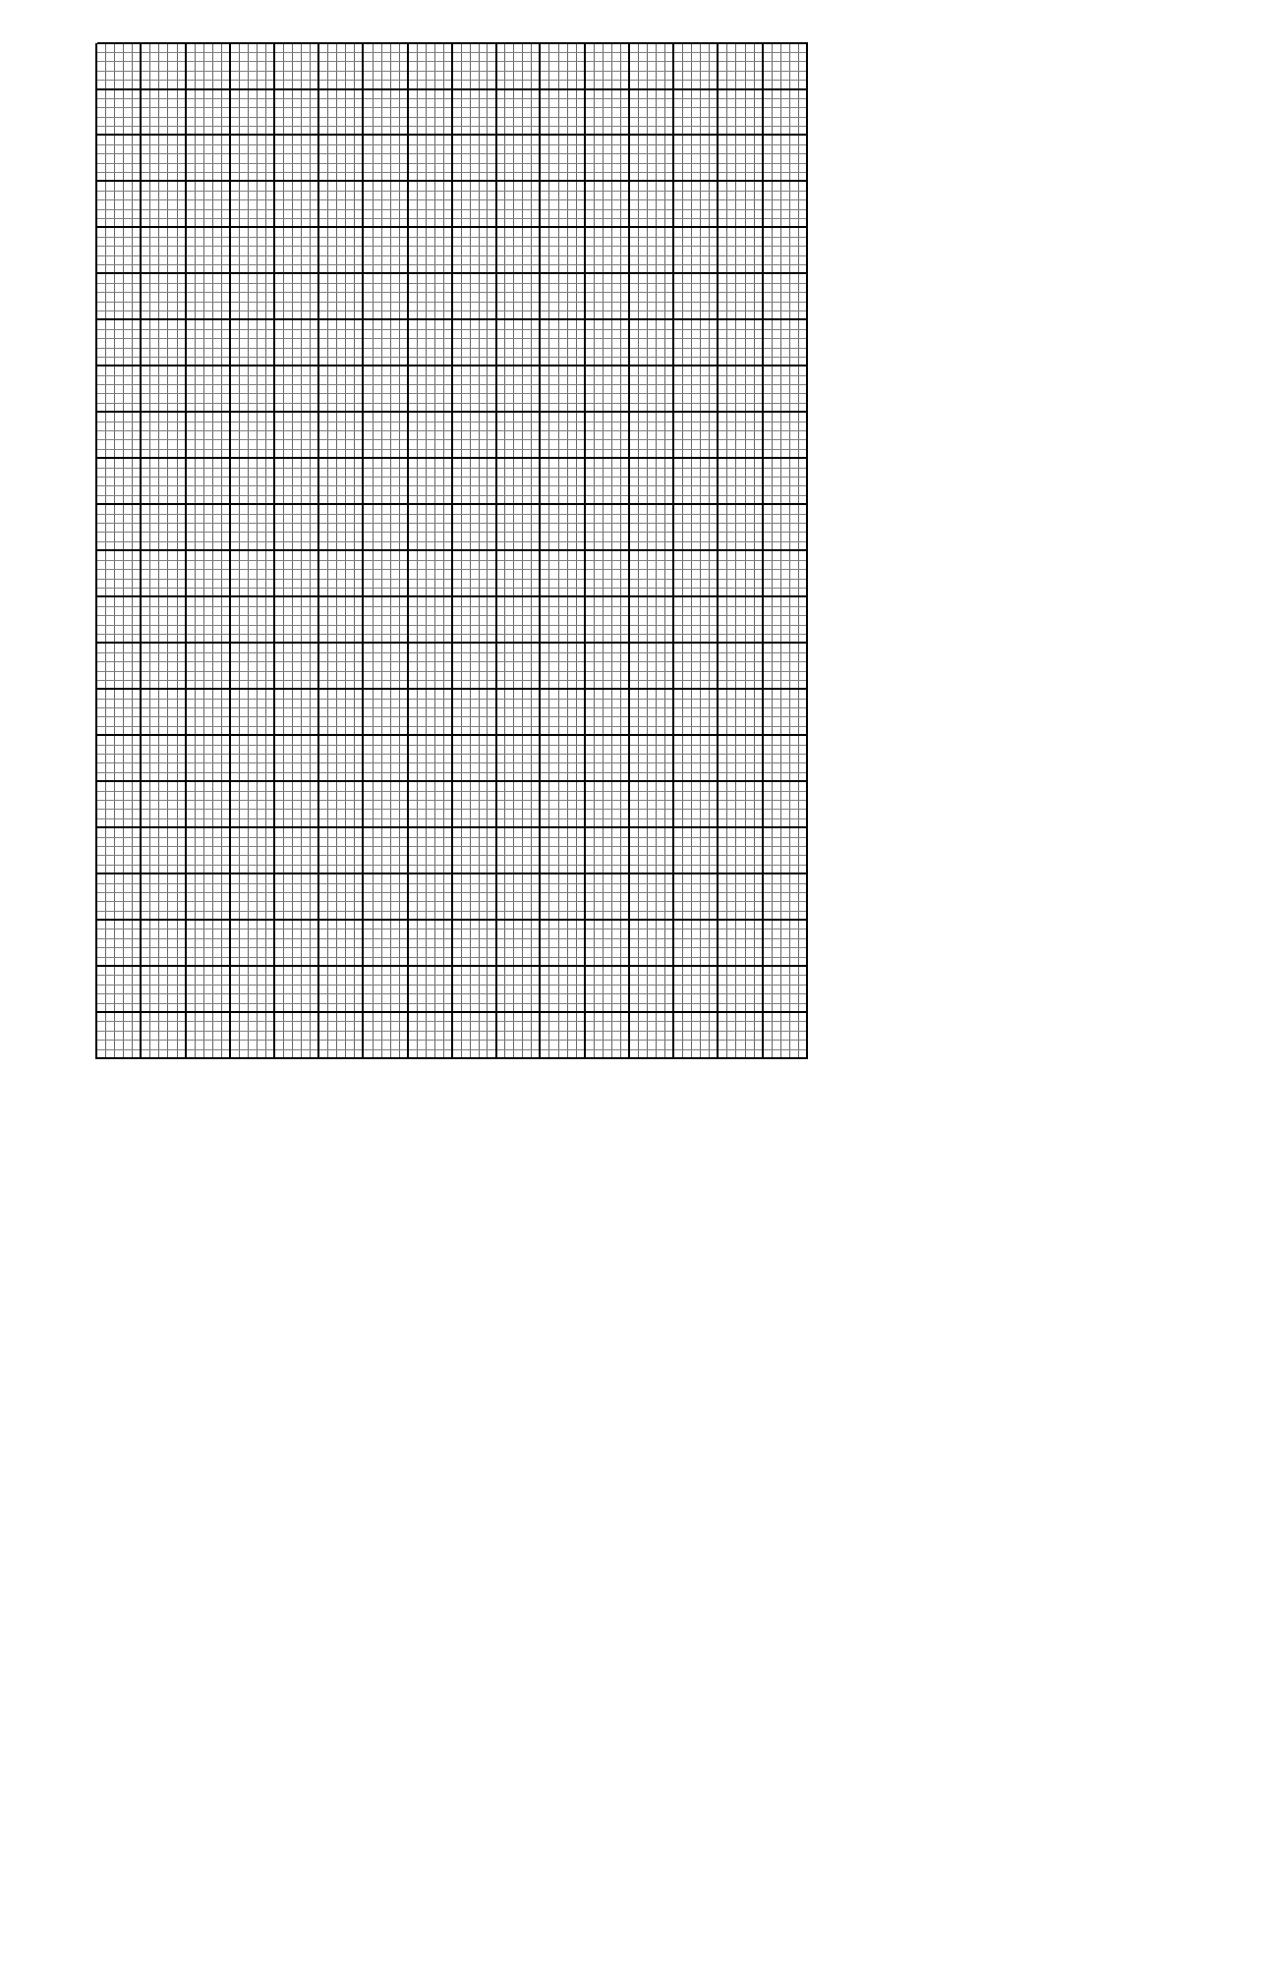

vii) From the graph, at d=50cm, determine
I) The slope s of the graph (3mks)

II) The value of k, given that (3mks)

2.A) You are provided with the following.
- A voltmeter
- An ammeter
- A switch
- 2 dry cells
- Cells holder
- Resistor R
- A nichrome wire mounted on mm scale
- 7 connecting wires
- Micrometer screw gauge
Proceed as follows
a) Measure the E.M.F, E of a cell (1mk)
E=…………………………………………………..

b) Draw the set up you have used to measure the E.M.F. (2mks)

c)I Using micrometer screw gauge provided measure the diameter d of the nichrome wire
d=…………………………………………………mm (1mk)
II Determine the radius r of the nichrome wire (2mks)

r=……………………………………………..m

d) Arrange the apparatus as shown below
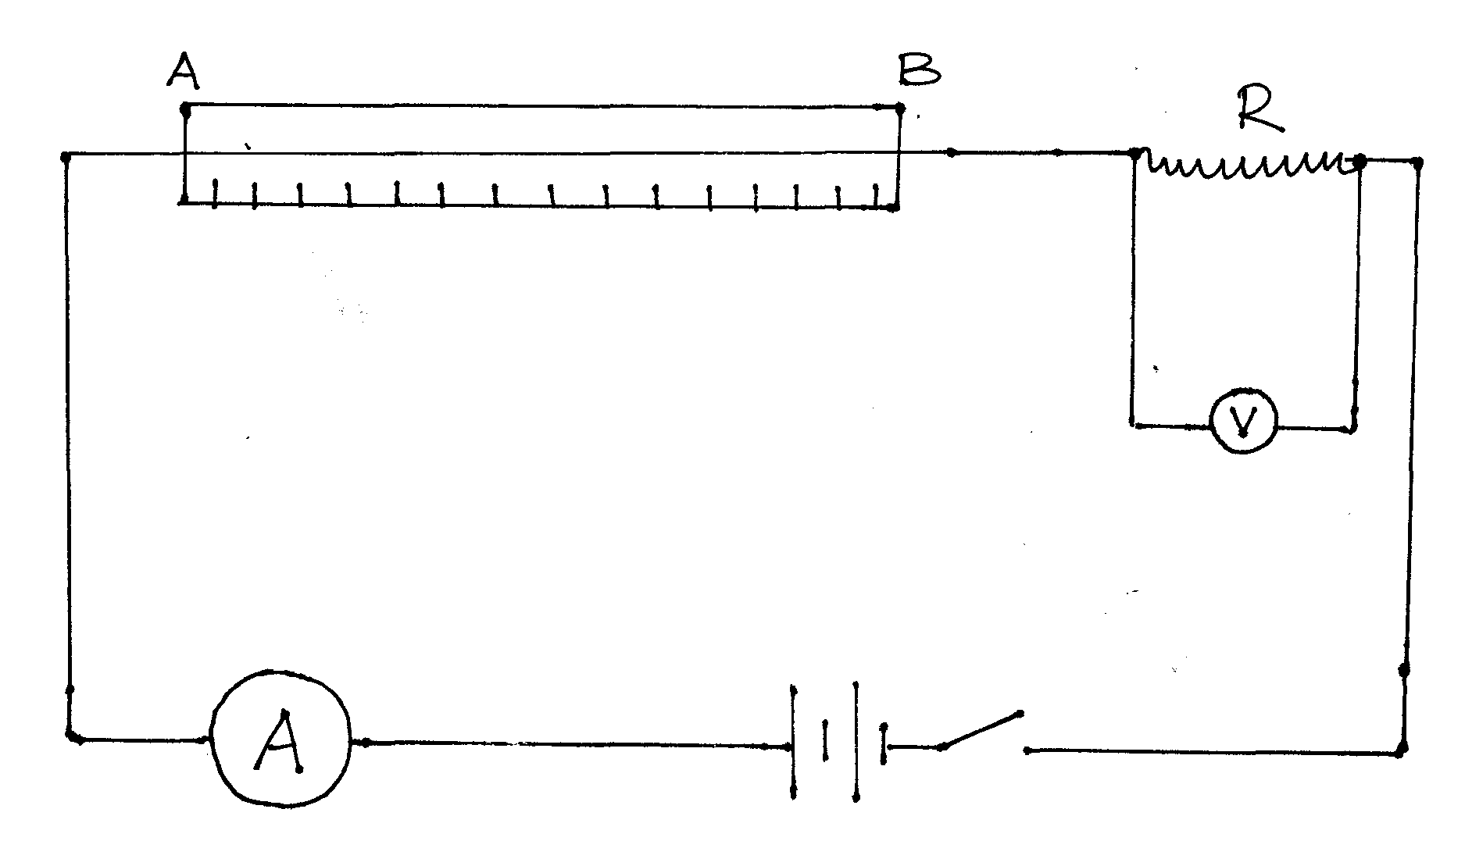
e) Close the switch and record V_{R}, the pd across resister and I_{R}, the current in the circuit
V_{R}………………………………… (1mk)
I_{R}…………………………………. (1mk)

f) Connect the voltmeter across nichrome wire AB and record the pd, V_{N}

V_{N}………………………………………………… (1mk)

g) Determine the value of resistance R (3mks)

h) Calculate the value of constant Q given that (3mks)

2.B) You are provided with the following set of apparatus.
- measuring cylinder
- Glycerine
- Two rubber bands
- One meter rule
- Steel ball bearing
- A magnet
- A micrometer screw gauge
- A stop watch
- A piece of tissue paper
a) Set the apparatus as shown
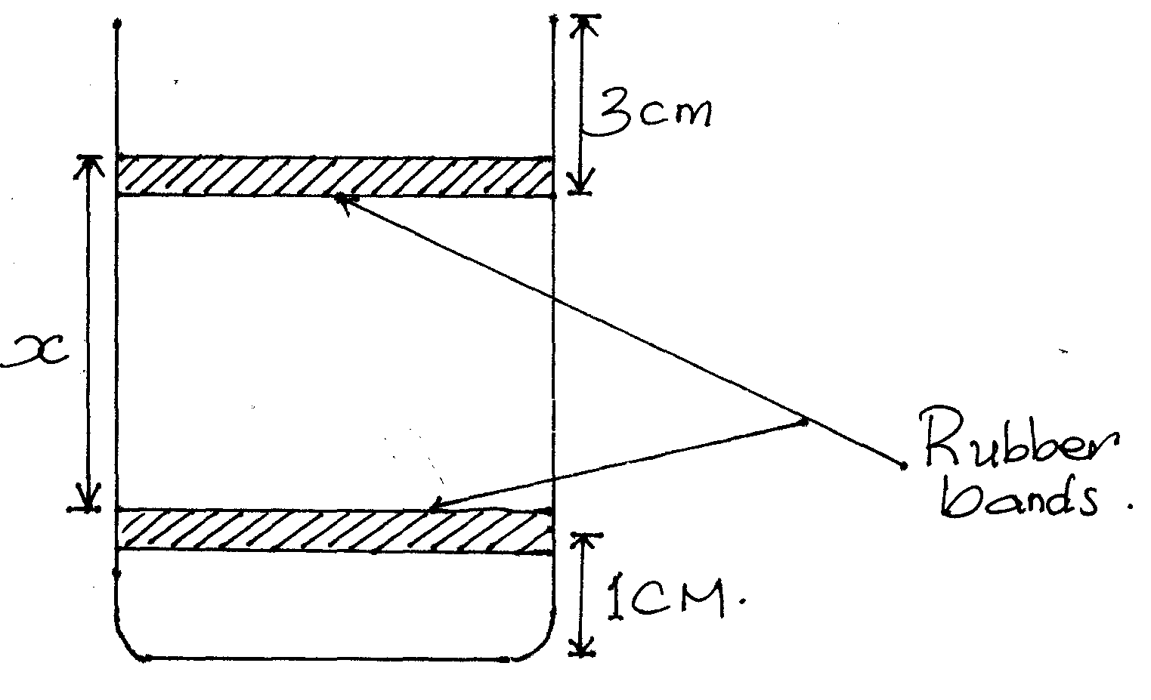
b) Adjust the lower ruber band so that x=25cm.
c) Release the steel ball from the surface of the liquid and obtain the time, t it takes to travel the distance x =25cm
t₁………………………………………. (1mk)

d) Use The magnet provided to remove the steel ball from the liquid.
e) Repeat procedure b, c and d for x= 15cm to obtain t₂
t₂=…………………………………………. (1mk)
f) Measure the diameter, D of the steel ball using micrometer screw gauge.
D=…………………………………..m (1mk)
g)I Calculate the average value of x and t
t_{av} = (1mk)

x_{av} = (1mk)

II) Using the average value obtained above, determine the viscosity of the glycerine using the equation below
(3mks)
Where g=acceleration due to the force of gravity =10m/s²
=density of steel bell = 7.0×10³kg/m³
D= Density of glycerin =1.26×10³kg/m³

THIS IS THE LAST PRINTED PAGE!

